**Mini Project Report**

on

**“Employee Management System”**

**Submitted by**

**PES1UG20CS816 : NAGESH B S**

1**: Activity Diagram:**

1. Usecase: Salary Management

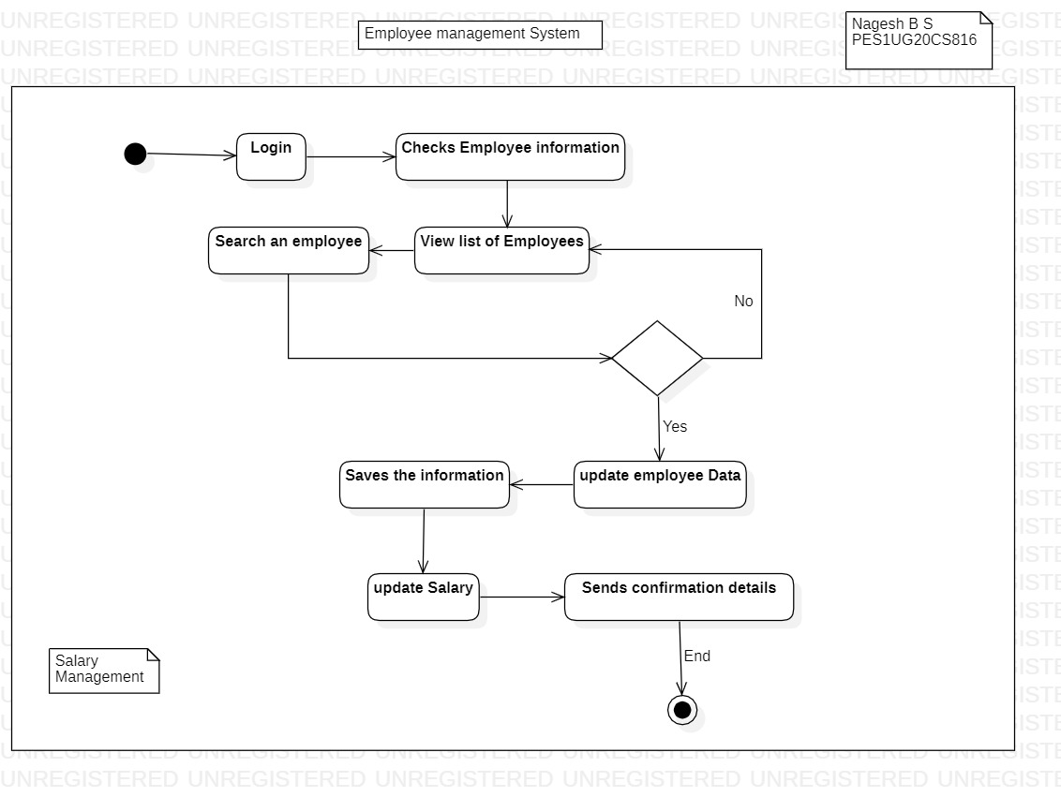

1. Usecase: Leave Management

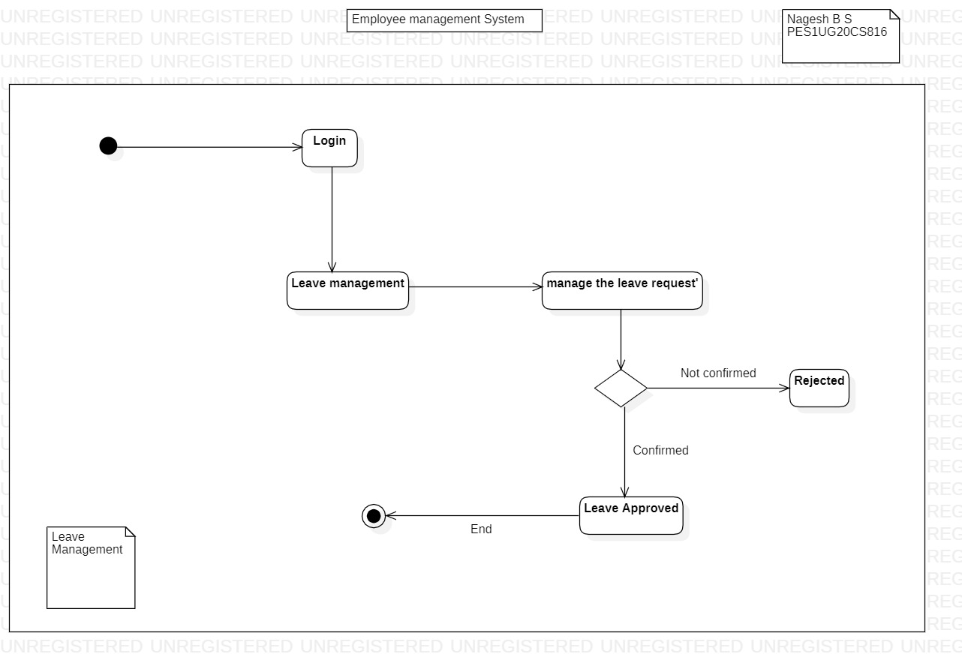

2: **State Diagram:**

1. UseCase: HR Management

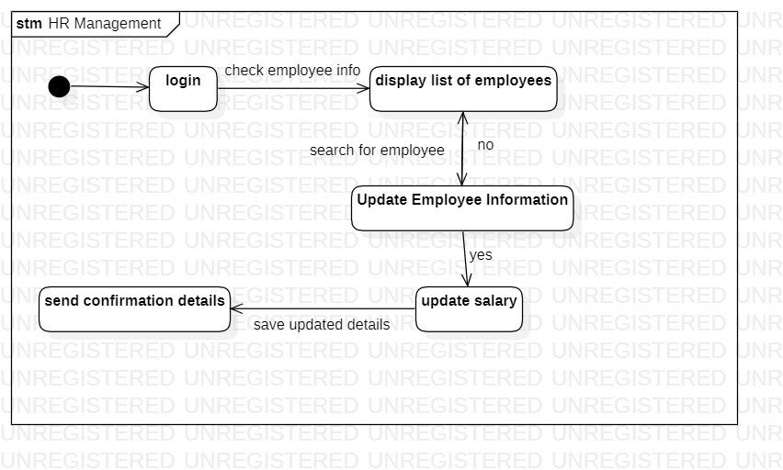

1. UseCase: Employee Management

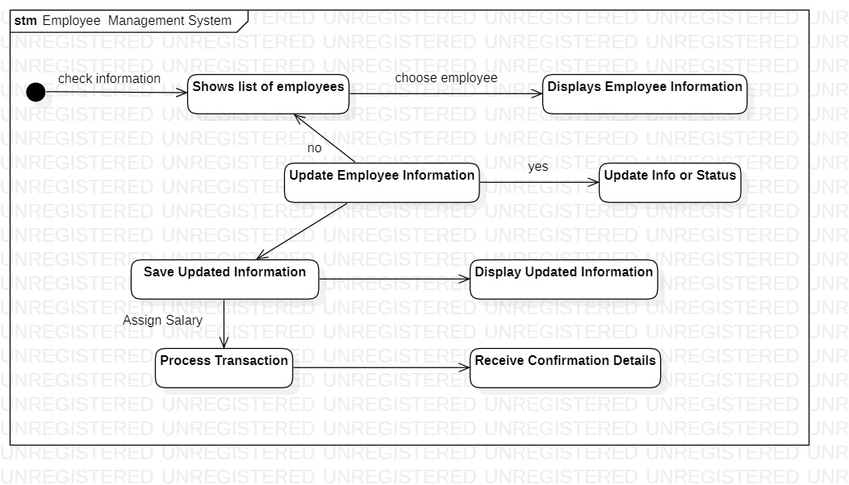

1. Usecase: Employee

